**PBL PROJECT REPORT**

# BASIC INFORMATION

College Name: College of Engineering, Trivandrum

Department: Electrical and Electronics Engineering

Course: Digital Electronics and Logic System Design (PBEOT304)

Semester: S3EL

Academic Year: 2025-26 (Odd)

Project Title: 4-BIT ALU

Name and Roll No. (Team Members) : GOWRIKRISHNA V (29)

GOWTHAM KRISHNA P K(30)

HARIKRISHNAN SANTHOSH (31)

HARIKRISHNA S(32)

SUDHEESH (64)

# ABSTRACT

**Problem Statement:** Modern computing relies fundamentally on the Arithmetic Logic Unit (ALU) for all data processing. This project addressed the need to practically realize and demonstrate the core operational and architectural principles of a processor’s central component, starting from the most basic digital building blocks.

**Objectives:** The primary objective was to design and implement a comprehensive 4-bit ALU using discrete digital components, specifically basic logic gates and flip-flops. The unit was designed to execute essential arithmetic operations (addition, subtraction, multiplication, and division) and foundational bitwise logical operations (AND, OR, XOR). The project also explicitly aimed to enhance the understanding of digital logic design by showcasing the internal structure of these data manipulation circuits.

**Methodology:** The design utilized a modular approach. Sub-circuits, such as the 4-bit ripple-carry adder (for addition and subtraction via two’s complement) and dedicated multiplication/division logic, were constructed using AND, OR, and XOR gates. Flip-flops were integrated for control and state management. A control unit, built with multiplexers and decoders, governed the selection of the desired operation. Rigorous testing was employed via simulation to verify the functionality and accuracy of all implemented operations against the required truth tables.

**Key Results:** The project successfully delivered a functioning, modular 4-bit ALU prototype. The implementation validated core principles of digital logic design, demonstrating how simple gates are combined into complex, functional processing units capable of fundamental data manipulation. This work serves as an essential foundation for understanding CPU internal architecture.

# 1. INTRODUCTION

The project is motivated by the fundamental role of the **Arithmetic Logic Unit (ALU)** in all digital computing. The ALU is essentially the "brain" of a Central Processing Unit (CPU) because it performs all the calculations and logical decisions needed to execute software instructions.

# 2. OBJECTIVES

List the main objectives of your project:

1.**Design and Implementation:** To successfully **design and construct a functional 4-bit ALU** using fundamental digital components, including basic logic gates (AND, OR, NOT, XOR) and flip-flops (for control and state).

2.**Operational Capability:** To ensure the implemented ALU is **capable of performing a defined set of fundamental operations**, which must include:

* **Arithmetic:** Addition, subtraction, multiplication, and division.
* **Logic:** Bitwise AND, OR, and XOR.

3. **Demonstrate Working Principle:** To **demonstrate the practical working of an ALU** by showing how it manipulates 4-bit data inputs according to a control signal that selects the desired operation.

**4. Educational Outcome:** To **enhance the understanding of digital logic design principles** and showcase the internal architecture of complex data manipulation circuits, thereby providing a foundational understanding of CPU operation.

# 3. METHODOLOGY

The project followed a four-stage, structured design methodology, ensuring that all functional and timing requirements were met before proceeding to physical construction.

**3.1 Problem Analysis –**

* The primary objective is to design and implement a comprehensive **4-bit Arithmetic Logic Unit (ALU)** using **discrete digital components (basic logic gates and flip-flops)** to execute essential arithmetic and bitwise logical operations.

* Circuit Design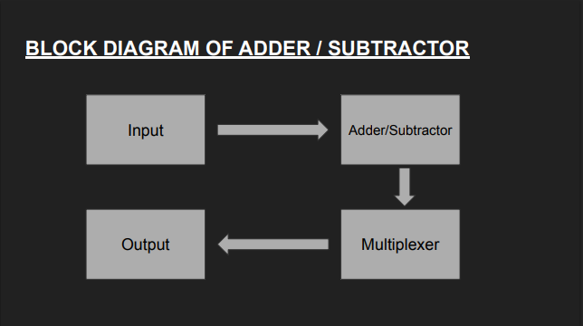
* 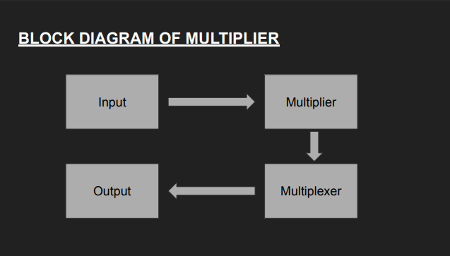
* Simulation – Tools used (e.g.Logisim, Proteus etc.)
* **3.4 Hardware Implementation** –   
     
  After successful verification through circuit simulation, the 4-bit Arithmetic Logic Unit (ALU) was realized as a physical, functional prototype. The implementation utilized a breadboard environment to facilitate easy assembly, modification, and debugging.
* **Sl. No Component Specification / Description**
* 1
* 2
* 3
* 4

5

* Testing and Troubleshooting – Verification of circuit operation

# 4. IMPLEMENTATION

**4.1 Circuit Diagram**

**SIMULATION DIAGRAM  
ALU   
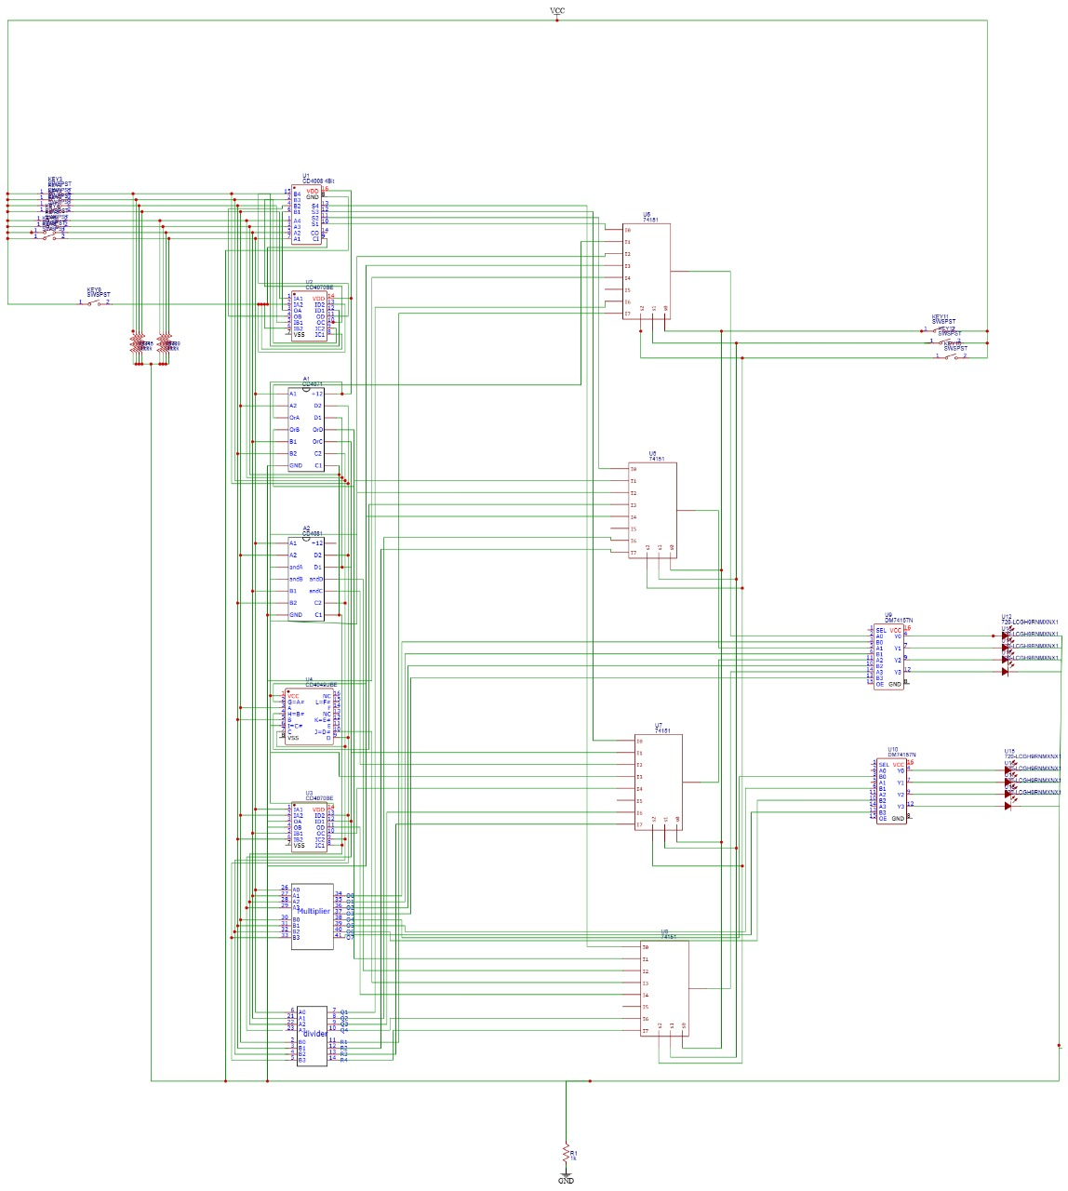  
MULTIPLIER  
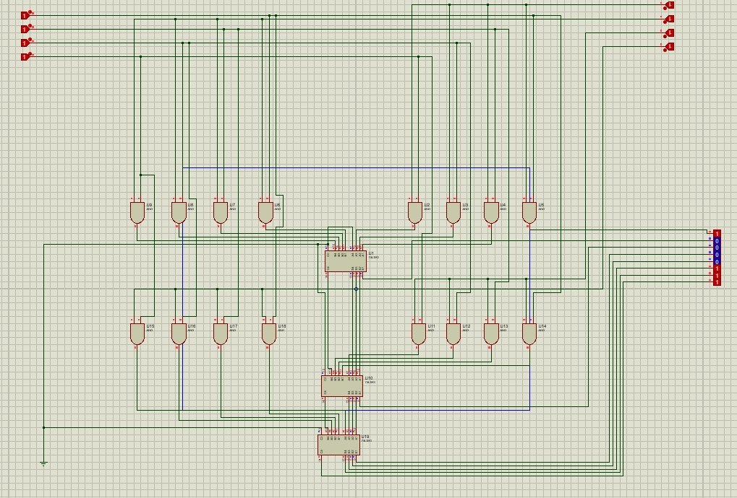**

**DIVIDER  
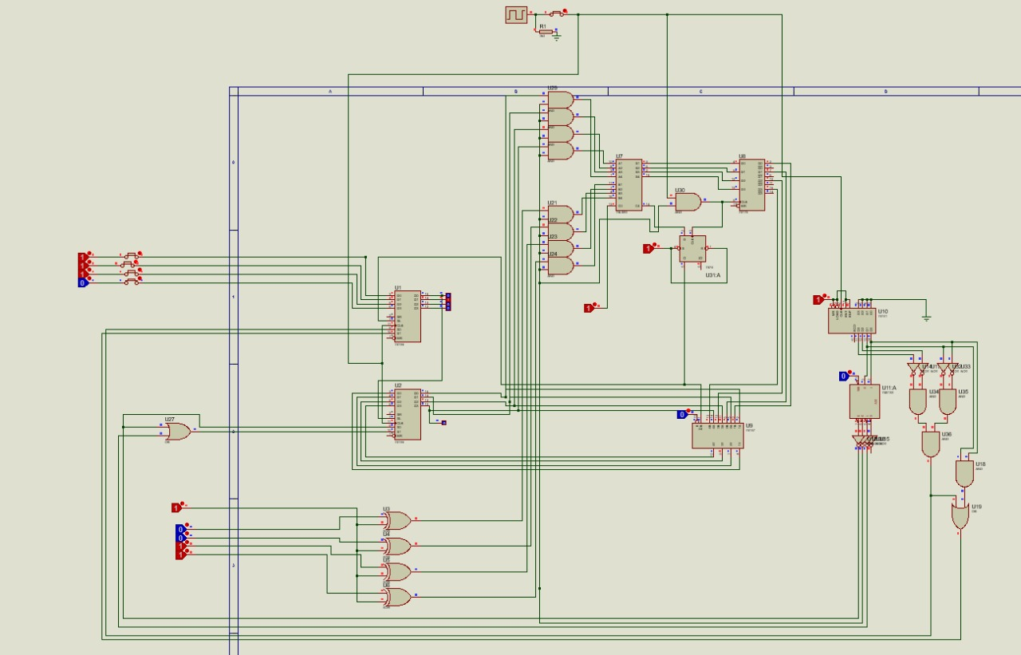**

* Simulation Results – Add simulation screenshots and explain outcomes.
* Hardware Implementation – Add photos and discuss results.

# 5. RESULTS The validation phase of the 4-bit ALU project involved comparing results obtained from two critical environments: software simulation (ideal logic) and physical hardware implementation (real-world performance). This comparison was essential for certifying the design's functional correctness and stability.

* **SIMULATION RESULT**

The circuit was first simulated using **Proteus Design Suite** to validate the logical operation of each subsystem. Key findings include:

# 6. INNOVATION AND APPLICATION

### Unique Features

The project's innovation lies in the **ground-up realization** and **comprehensive functional integration** of the 4-bit ALU. It is unique because it:

1. **Integrated the MULTIPLIER AND DIVIDER CIRCUIT which made the circuit much cost effective.**
2. Employs a **modular design** (AU, LU, Control) that directly reflects the **VLSI architecture** used in commercial processors, providing a scalable blueprint.

### Real-World Applications

The 4-bit ALU serves as a fundamental model for all digital electronics, with direct applications in:

* **Microprocessor Architecture:** It is the conceptual core of every **CPU and GPU** , teaching the basics of the data path, control logic, and flag management.
* **Embedded Systems:** Its principles are used in low-power **microcontrollers** and digital sensors.
* **Hardware Design Skills:** The process validates skills necessary for designing custom digital logic using **Hardware Description Languages (HDL)** for **FPGAs** and **ASICs**.

# 7. CHALLENGES AND TROUBLESHOOTING

Faced availability

# 8. CONCLUSION

Summarize your findings, project outcomes, and scope for future improvement.

# 9. REFERENCES

Floyd, T. L. (2015). Digital Fundamentals (11th Edition). Pearson Education.   
  
Malvino, A. P., & Leach, D. P. (2017). Digital Principles and Applications (8th Edition). McGraw-Hill Education.  
   
Boylestad, R. L. (2016). Electronic Devices and Circuit Theory (11th Edition). Pearson Education.

* Datasheet – 74LS86 Quad 2-Input XOR Gate, Texas Instruments**,** Available at: *[Insert URL link to a 74LS86 datasheet]*
  + *Used for bitwise XOR operations and as a core component in the Full Adder and Subtractor circuits.*
* Datasheet – 74LS32 Quad 2-Input OR Gate, Texas Instruments, Available at: *[Insert URL link to a 74LS32 datasheet]*
  + *Used for bitwise OR operations and general combinatorial logic.*
* Datasheet – 74LS08 Quad 2-Input AND Gate, Texas Instruments, Available at: *[Insert URL link to a 74LS08 datasheet]*
  + *Used for bitwise AND operations and general combinatorial logic.*
* Datasheet – 74LS151 8-to-1 Line Data Selector/Multiplexer, Texas Instruments, Available at: *[Insert URL link to a 74LS151 datasheet]*
  + *Essential for the ALU's output stage to select the result from the correct functional unit (Arithmetic or Logic).*
* Datasheet – 74LS83 4-Bit Binary Full Adder, Texas Instruments, Available at: *[Insert URL link to a 74LS83 datasheet]*
  + *If utilizing a pre-packaged adder IC, this datasheet details pinouts and ripple-carry functionality.*

# 10. APPENDIX

Include datasheets, code snippets, or additional figures if required.